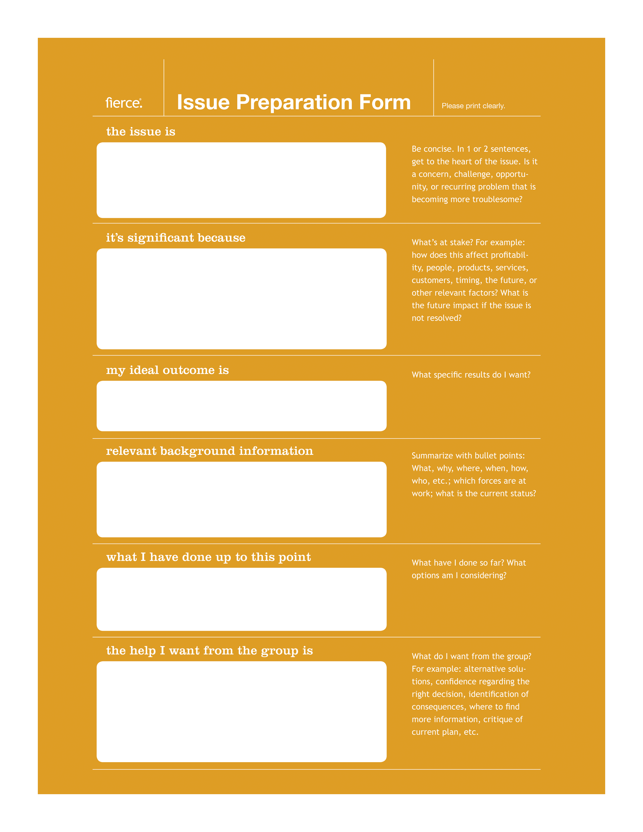
Describe issue here
Explain the significance
Image ideal outcome
Provide background info
Explain progress / options
Request assistance

